1. A 51-year old African American male with a 20-year history of smoking and alcoholism as well as diverticulitis presents to his primary care physician complaining of chest pain. He associates this with coughing that occurs while he is trying to fall asleep. He has also recently had trouble swallowing foods and liquids and his partner has complained that he has bad breath. A barium swallow was ordered and can be seen below. His mother died years ago of esophageal cancer. He has lost a considerable amount of weight. An endoscopic biopsy is performed, what is the most likely diagnosis?

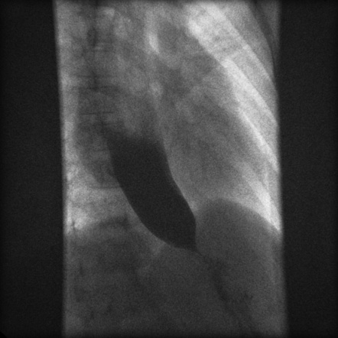

1. Adenocarcinoma
2. Squamous cell carcinoma
3. Small cell carcinoma
4. Carcinoid tumor
5. MALT lymphoma
6. The parents of a 5-year old male present to the pediatrician concerned that the boy is too small for his age. The child is observed to have dental abnormalities and frontal bossing. The grandfather and mother both have dental abnormalities as well. Lab values reveal elevated phosphate and low calcitriol, everything else is normal. An x-ray is shown below. What is the likely treatment and diagnosis?

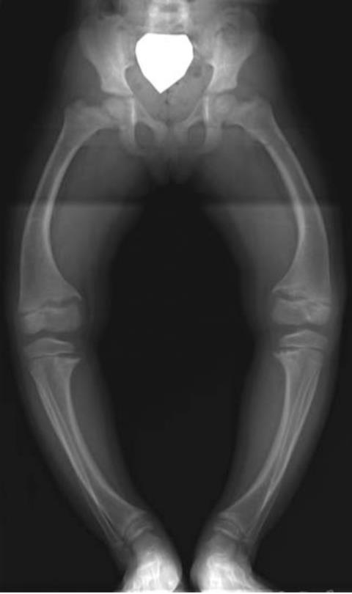

1. Cholecalciferol, Calcitriol, Phosphorus; Vitamin D Deficiency Rickets
2. Calcitriol; Vitamin D Resistant Rickets
3. Cholecalciferol, Calcitriol, Phosphorus; Vitamin D Resistant Rickets
4. Phosphorus; Hypophosphatasia
5. Cholecalciferol, Phosphorus; Hypophosphatasia
6. A 71-year old woman presents to her physician complaining of right shoulder pain. She was bowling with her partner a week ago and was using a heavier ball than normal when she felt a sharp pain in her right shoulder. She has since felt pain when abducting her right arm to the point where she can no longer dress herself and says her right shoulder feels less stable. She is able to adduct, extend, medially rotate, and laterally rotate her arm otherwise without discomfort. An MRI of her shoulder is shown below. Which muscle is likely injured?

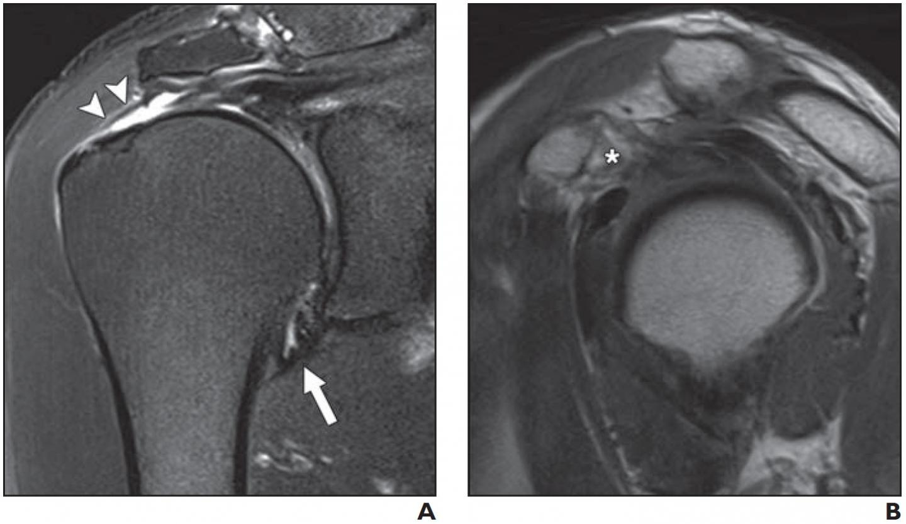

1. Deltoid muscle
2. Infraspinatus muscle
3. Subscapularis muscle
4. Supraspinatus muscle
5. Teres minor muscle
6. Match the following 3 chest radiographs with their appropriate pathology. The arrows may be helpful in answering this.

Aortic stenosis; Normal; Systemic hypertension

Appearances of the Aorta; Learning Radiology: Recognizing the Basics, 4ed (© Elsevier, Inc. 2020)

1. Normal
2. Aortic stenosis
3. Systemic hypertension

Explanation:

1. Normal: The ascending aorta is a low-density, almost straight edge (solid white arrow) and does not project beyond the right heart border (dotted white arrow). The aortic knob is not enlarged (double arrow) and the descending aortic (solid black arrow) almost disappears with the shadow of the thoracic spine.
2. Aortic stenosis: The ascending aortic is abnormal as it projects convex outward (solid white arrow) almost as far as the right heart border (dotted white arrow). This is secondary to post-stenotic dilatation. The aortic knob (double arrow) and descending aorta (solid black arrow) remain normal.
3. Systemic hypertension. Both the ascending (solid white arrow) and descending aorta (solid black arrow) project too far to the right and left, respectively. The aortic knob is enlarged (double black arrow).
4. A 25-year-old male medical student presents with severe low back pain for the past 4 months. He initially attributed the pain from sitting his chair all day while studying for Step 1, but he still experiences the severe pain in the morning until he walks around the clinic. An X-Ray is obtained and is pictured below. Which of the following additional symptoms is NOT more likely to occur in this patient?

1. Peripheral arthritis
2. Aortic regurgitation
3. Uveitis
4. Hearing loss
5. Enthesitis

Explanation: This patient likely has ankylosing spondylitis. Here is a picture from First Aid that gives a good summary of seronegative spondyloarthritis and their subtypes:

