Question 1 (2 points)

Ms. Smith is a 23-year-old female with no significant medical history presenting with ulnar sided wrist pain which has persisted for three weeks. She provides that she competes on her college golf team and has been competing regularly over the past two months. Exam shows motor weakness of the intrinsic hand muscles and tenderness over the hypothenar eminence. Which of the following carpal bone injuries is most likely?

1. 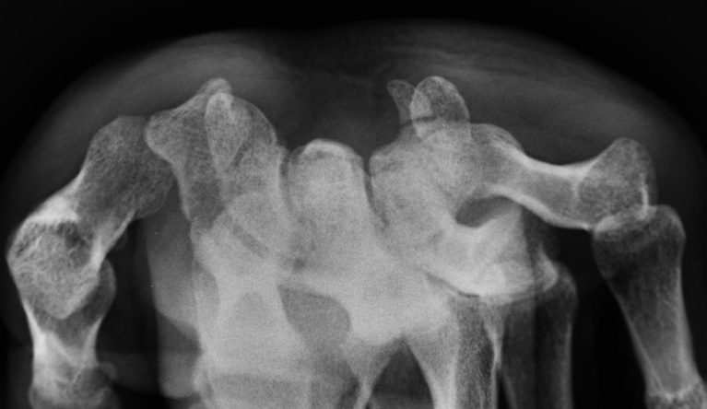Dislocation of the lunate
2. Hamate fracture
3. Scaphoid fracture
4. Pisiform fracture

Case courtesy of Dr Maulik S Patel, Radiopaedia.org, rID: 72958

<https://www.orthobullets.com/hand/6035/hook-of-hamate-fracture>

This carpal tunnel view XR of the hand shows an undisplaced hook of hamate fracture. The hook of hamate contributes to Guyon’s canal which houses the ulnar nerve. Injury to the hook of hamate is relatively uncommon but is typically caused by a direct blow to the volar proximal palm (ex. grounding of a golf club). The injury is often delayed in its diagnosis with an average of 4 weeks from injury to diagnosis.

Question 2 (1 point)

Presentation: Acute onset shortness of breath following trauma

What is the likely diagnosis?

1. Simple pneumothorax
2. Pleural effusion
3. Hemothorax
4. Tension pneumothorax

Case courtesy of Dr Ian Bickle, Radiopaedia.org, rID: 77654

https://radiopaedia.org/articles/tension-pneumothorax?lang=us

Tension pneumothorax is easily diagnosed with CXR. Imaging shows a collapsed right lung as seen in simple pneumothorax in addition to contralateral shift of the mediastinum. Ipsilateral increase in intercostal spaces can also be seen in some cases. Rapid recognition and decompression are essential.

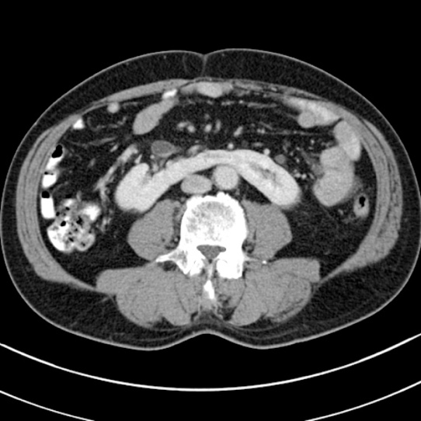During the workup for nephrolithiasis, the following is incidentally found. This lower pole fusion of the kidneys is most likely trapped below which of the following:

1. Common iliac artery
2. Inferior mesenteric artery
3. Superior mesenteric artery
4. Celiac trunk

Case courtesy of Dr Ian Bickle, Radiopaedia.org, rID: 39192

https://www.ncbi.nlm.nih.gov/books/NBK431105/

Horseshoe kidney is the most common fusion defect of the kidneys. While usually asymptomatic, increased rates of nephrolithiasis are seen. The kidneys often sit low in the abdomen due to entrapment below the IMA.

(1-point question)

What is the type of fracture presented in the radiograph below?

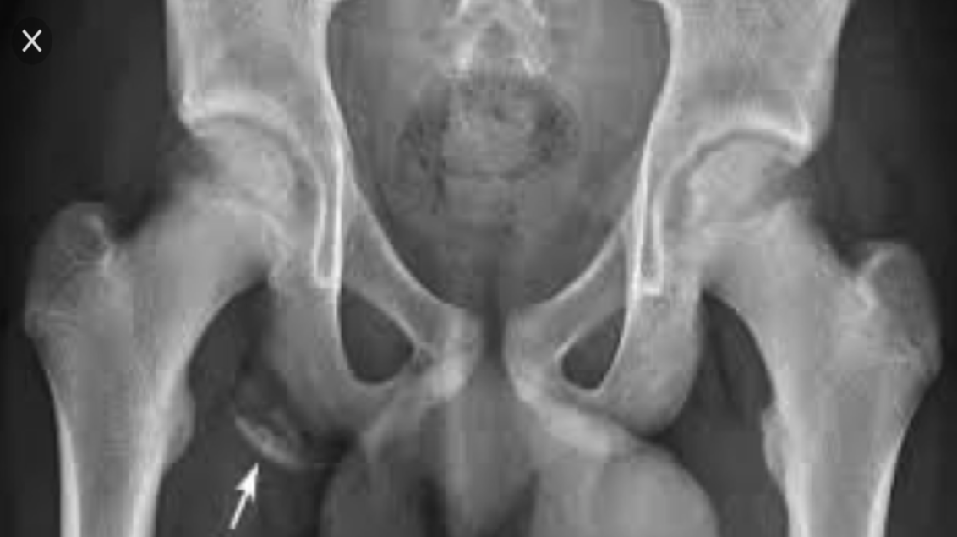

A: Traumatic comminuted butterfly fracture

B: Pathologic fracture

C: Fatigue stress fracture

D: Insufficiency stress fracture

E: Avulsion fracture

Correct answer: E: Avulsion fracture

(3-point question)

After you return home for the holidays your uncle, knowing that you are a medical student, asks you interpret his hand x-ray study (below). He is an overweight male in his late fifties with a thirty pack-year smoking history. A note on the image states joint subluxations, marginal erosions, and soft tissue swelling are present. What condition does your uncle most likely have?

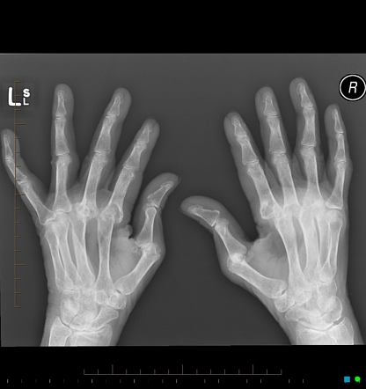

A: Osteoarthritis

B: Psoriatic arthritis

C: Rheumatoid arthritis

D: Gout

E: Septic arthritis

Correct answer: C: Rheumatoid arthritis