- What is the correct order of tissue or structures on radiographs from most opaque to least opaque? (1 point)

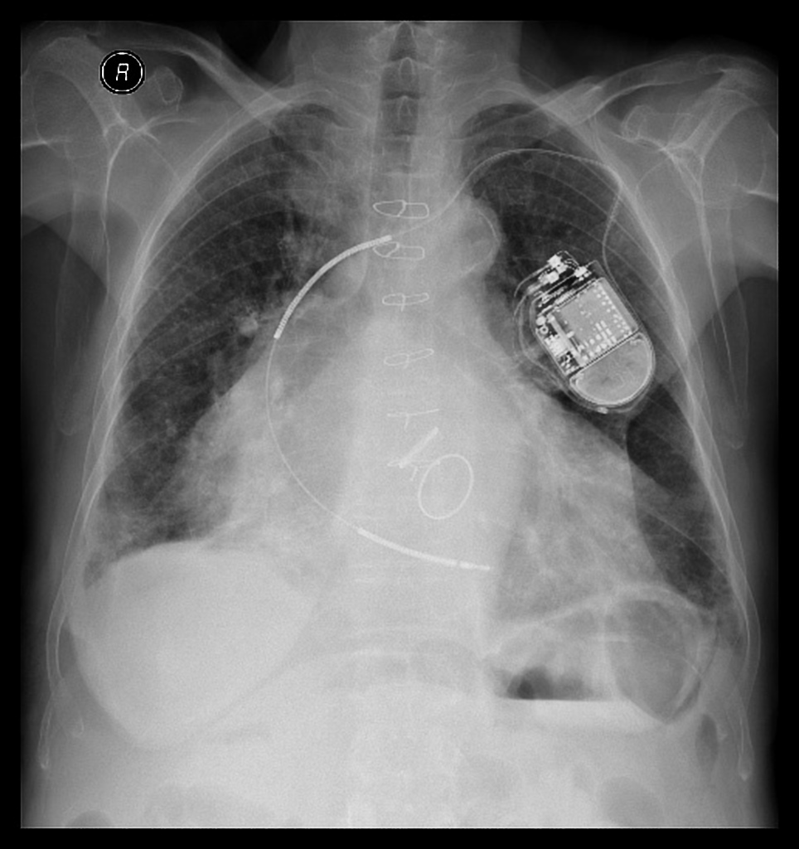
Case courtesy of Dr Varun Babu, Radiopaedia.org, rID: 44984

- Metal, bone, soft tissue, fat, air
- Bone, metal, soft tissue, fat, air
- Metal, bone, fat, soft tissue, air
- Air, fat, soft tissue, bone, metal
- Air, soft tissue, fat, bone, metal
The correct answer is A. Tissue with higher density is more opaque on radiographs. The Alliance of Medical Student Educators in Radiology (AMSER) objective for this case is:
Categorize different tissues from most to least opaque on x-ray including: bone, soft tissue, air, metal, and fat.

- What is the diagnosis and in what position was the patient in when this chest radiograph was obtained? (2 points)
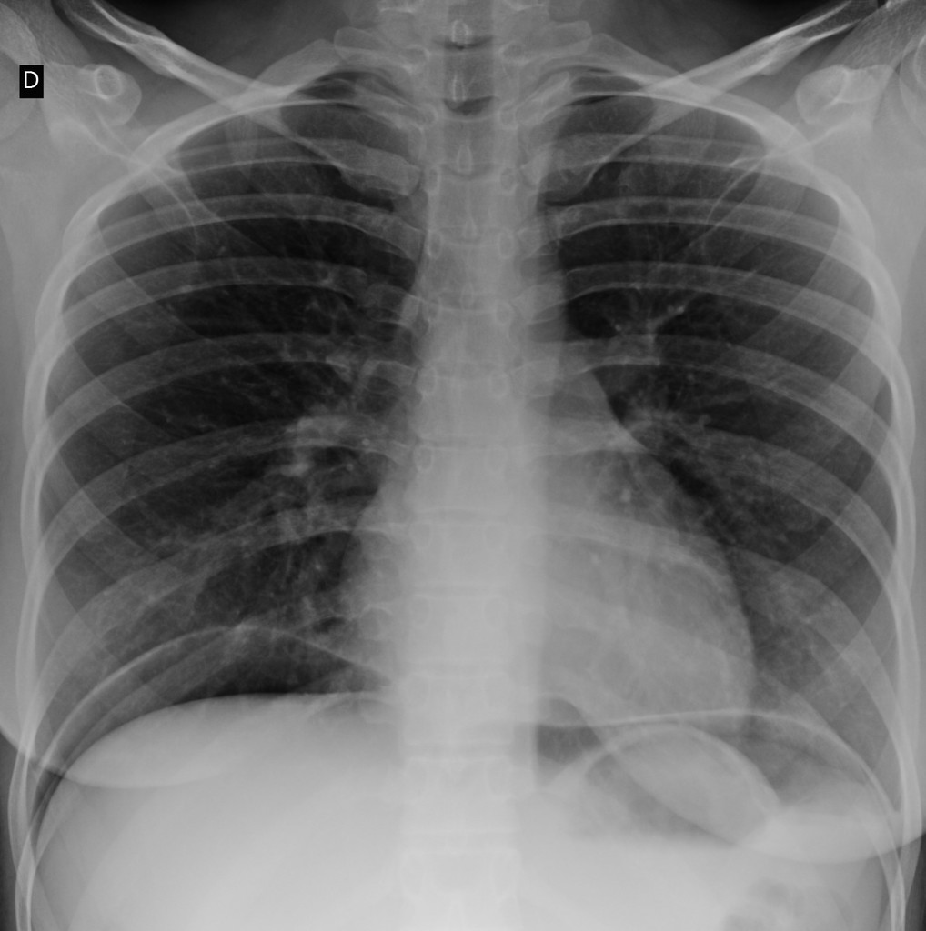
Case courtesy of Dr Guilherme Pioli Resende, Radiopaedia.org, rID: 81470

- Pneumothorax, upright
- Pneumothorax, supine
- Pneumoperitoneum, supine
- Pneumoperitoneum, upright
- Pneumomediastinum, upright

The correct answer is D. The superior and inferior margins of the diaphragm silhouette are visible because a silhouette is created by air in the lung above the diaphragm and free intra-peritoneal air below the diaphragm. The patient must be upright for free air to collect under the diaphragm and for a horizontal air-fluid level to form in the stomach. Free intra-abdominal air is best recognized on upright chest, upright abdomen, or left lateral decubitus abdomen radiographs and is more difficult or not possible to identify on supine radiographs. The AMSER objective for this case is: Recognize free intra-abdominal air on plain film and describe how patient positioning may affect sensitivity for its detection.
- This wrist radiograph shows a fracture of the most commonly fractured carpal bone. Which bone is fractured? (1 point)
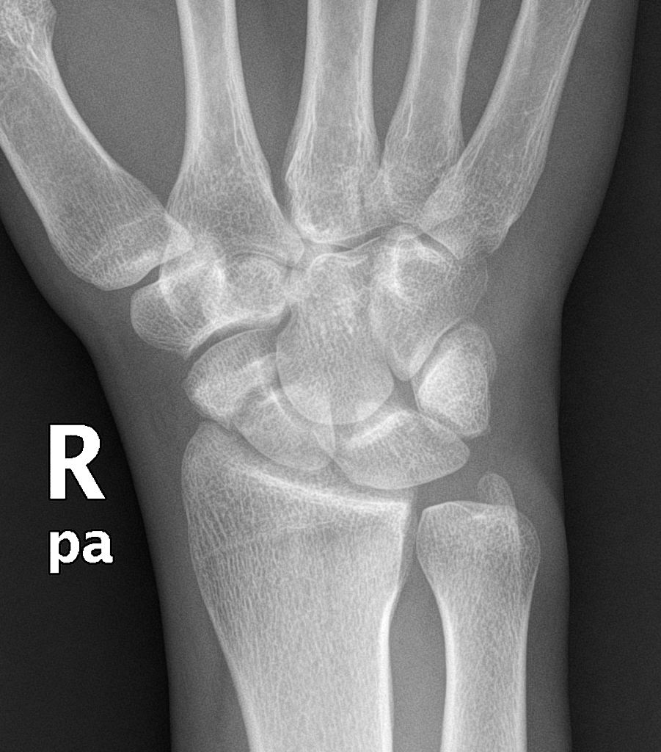
Case courtesy of Dr Hani Makky Al Salam, Radiopaedia.org, rID: 13037

- Triquetrum
- Lunate
- Hamate
- Capitate
- Scaphoid
The correct answer is E. The fracture is recognized as a lucency across the scaphoid waist. The scaphoid is the most commonly fractured carpal bone. These are the AMSER objectives for this case:
Recognize a non-displaced fracture on x-ray.
Identify and name the major parts of the following bones on x-ray: Humerus, radius, ulna, carpal bones, metacarpals and phalanges, femur, fibula, tibia, tarsal bones, calcaneus, metatarsals, vertebrae, ribs, pelvis, clavicles, and scapulae.

- This patient sustained a head injury in a motor vehicle accident. A head CT without contrast was performed. There is midline shift from left to right indicating subfalcine herniation. What is the cause of the shift? (1 point)
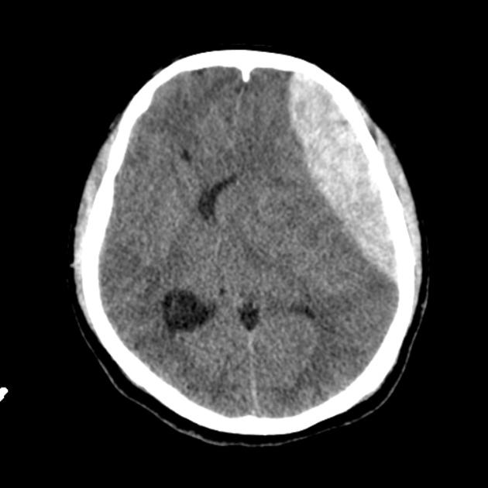
Case courtesy of Dr David Cuete, Radiopaedia.org, rID: 29440
- Subdural hematoma
- Epidural hematoma
- Intra-parenchymal brain hemorrhage
- Scalp hematoma
- Intra-ventricular hemorrhage
The correct answer is B. The epidural hematoma is recognized as an area of increased density with a convex margin with the brain. It has mass effect causing midline shift. The AMSER objective for this question is:
Discriminate between a subdural and epidural hematoma at CT.

- This is a normal CT image of the upper abdomen. Which statement is correct? (2 points)

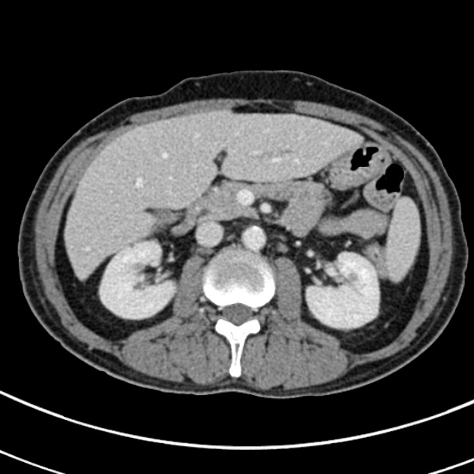
Case courtesy of Dr Ian Bickle, Radiopaedia.org, rID: 38003
- Intravenous contrast was used.
- Intravenous contrast was not used.
- Oral contrast only was used.
- Intravenous and oral contrast were both used.
- No contrast agents were used.
The correct answer is A. There is contrast enhancement of the liver, kidneys, spleen, aorta, inferior vena cava, superior mesenteric vein, superior mesenteric artery, and portal and hepatic veins in the liver. There is no contrast material in the GI tract. Medical students should understand that CT scans can be done with or without intravenous contrast and should be able to recognize contrast enhancement. They should also know that oral GI contrast material may be used and will be seen as increased density in the GI tract. The AMSER objectives for this case are:
Distinguish between the different types of contrast used in imaging exams and the potential diagnostic benefits of each.
Structures that should be identified on each modality: Liver, spleen, aorta, IVC, stomach, small bowel, colon.

