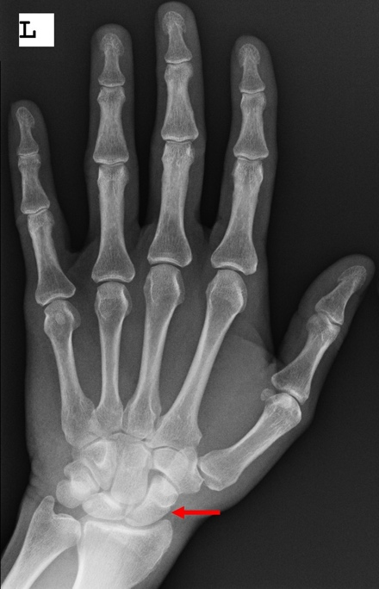**Round 6 RadiOlympics**

**Questions 1-3 by Tonuka Chatterjee, Meharry Medical College**

**Question 1**

* *Image: left hand xray*
  + Image courtesy of Pickering Diagnostic Imaging Centre
* Identify the bone as indicated by the red arrow on the hand X-ray.
  + Trapezium
  + Lunate
  + **Scaphoid (CORRECT)**
  + Metacarpal bone
  + Radius

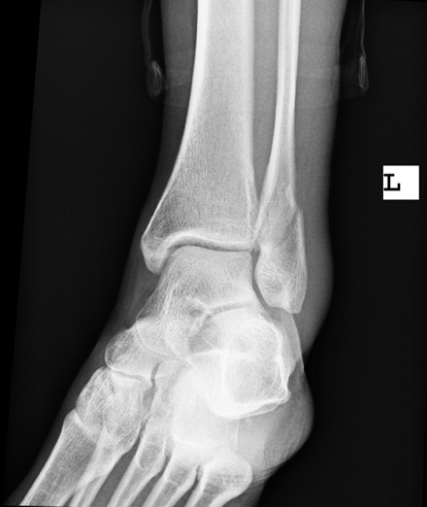**Question 2**

* *Image: ankle fracture*
  + Image courtesy of Pickering Diagnostic Imaging Centre
* A 40-year-old male patient presents to the ED with pain and swelling of the lateral aspect of the left ankle following a twisting injury as he was climbing down the stairs at home. What is the diagnosis?
  + Normal
  + Exostosis of the lateral malleolus
  + **Fracture of the lateral malleolus (CORRECT)**
  + Dislocation of the ankle
  + Fracture of the calcaneus

**Question 3**

* A 12-year-old female presents to the ED with her parents with pain in her right elbow. The patient had been playing with her siblings in their backyard when she fell on an outstretched right hand. X-ray of her right elbow shows a medial epicondyle fracture of the humerus. What symptoms will the patient experience?
  + Loss of sensation over the 1st digit
  + **Weak flexion of the 5th digit (CORRECT)**
  + Weak shoulder adduction
  + Inability to flex the MCP and extend the DIP and PIP of the 1st and 2nd digits
  + Protrusion of the scapula outward when pushing on a wall

Questions made by Sawyer Goetz, University of Iowa

https://radiopaedia.org/articles/situs-inversus

Abnormal EKG findings were recorded during the evaluation of a man admitted with rectal bleeding and anemia. A chest radiograph was taken and the resulting image is shown above. Going forward, what will be a necessary element of medical care for this patient? (2-3 points)

1. Transthoracic echocardiogram
2. Repeat imaging with proper patient positioning
3. Heart surgery
4. Reversal of EKG lead placement

Explanation: This patient has a condition known as situs inversus totalis. His organs are flipped anatomically in a mirror image so that his heart sits on the right side, his liver on the left, etc. This congenital change occurs in around 1 in 10,000 people, is asymptomatic, and is often found incidentally. However, because of the atypical anatomy demonstrated by these patients, EKG lead placement, defibrillator pad placement, and cardiac auscultation should be adjusted to account for the reversed position of the heart.

Who discovered X-Rays and went on to receive the inaugural Nobel prize in physics? (1 point)

1. Marie Curie
2. Raymond Damadian
3. Wilhelm Röntgen
4. Godfrey Hounsfield