1. (1 point) What type of image is depicted below?

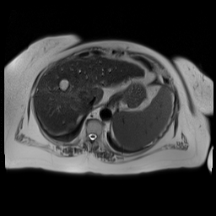

a.) Computed tomography (CT) with iodinated intravenous contrast
b.) T2-weighted magnetic resonance image (MRI)
c.) Computed tomography (CT) without iodinated intravenous contrast
d.) T1-weighted magnetic resonance image (MRI)

2.) (1 point) A patient presents with persistent arm pain and reduced range of motion. Ultrasound was performed of the antecubital fossa. What structure is most likely indicated by the arrows?
Compression

a.) Brachial artery
b.) Deep vein
c.) Median nerve
d.) Radial artery
d.) Superficial vein

3.) (2 points) An in-office ultrasound was performed on a patient with persistent RUQ pain and the image below was obtained. What finding is indicated by the arrow?

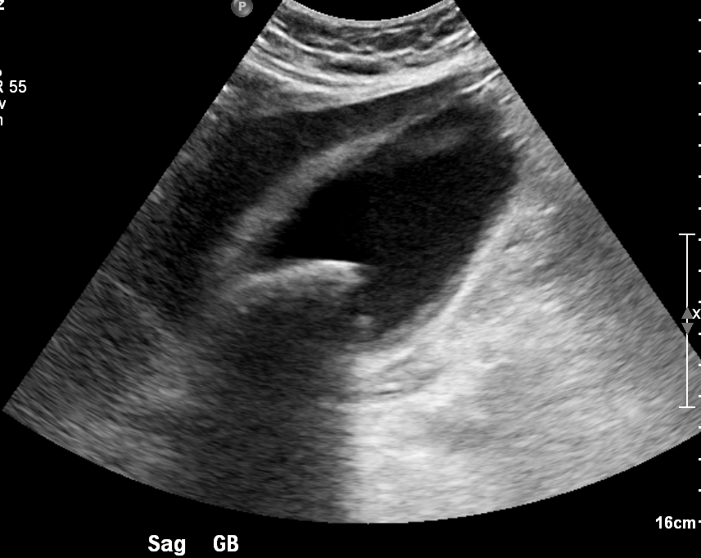

a.) Posterior acoustic enhancement deep to the gallbladder
b.) Posterior acoustic shadowing deep to a gall stone
c.) Inflammatory fat stranding due to acute cholelithiasis
d.) Echogenic liver parenchyma due to hepatic steatosis

4.) (3 points) A 61-year-old patient presents with abdominal distension. What is the most likely diagnosis?

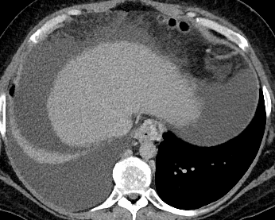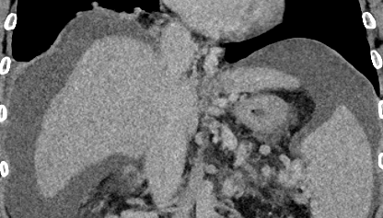

a.) Hepatic steatosis
b.) Hepatic metastasis
c.) Hepatic cirrhosis
d.) Peritoneal carcinomatosis
e.) Hemoperitoneum

5.) (3 points) Based on radiographic appearance alone, what diagnosis is most likely associated with the axial CT shown below?

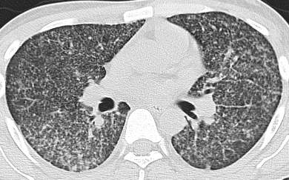

a.) Primary bronchogenic carcinoma
b.) COVID-19 pneumonia
c.) Disseminated histoplasmosis
d.) Idiopathic pulmonary fibrosis
e.) Coal workers’ pneumoconiosis

Key

1: b.) T2-weighted magnetic resonance image (MRI)
2: b.) Deep vein
3: a.) Posterior acoustic enhancement deep to the gallbladder
4: c.) Hepatic cirrhosis
5: c.) Disseminated histoplasmosis

