**Vanderbilt University School of Medicine RadiOlympics Questions**

Author: Dennis Zhou (MS3)

Reviewer: Dr. Jennifer Huang, MD (Diagnostic Radiology Resident)

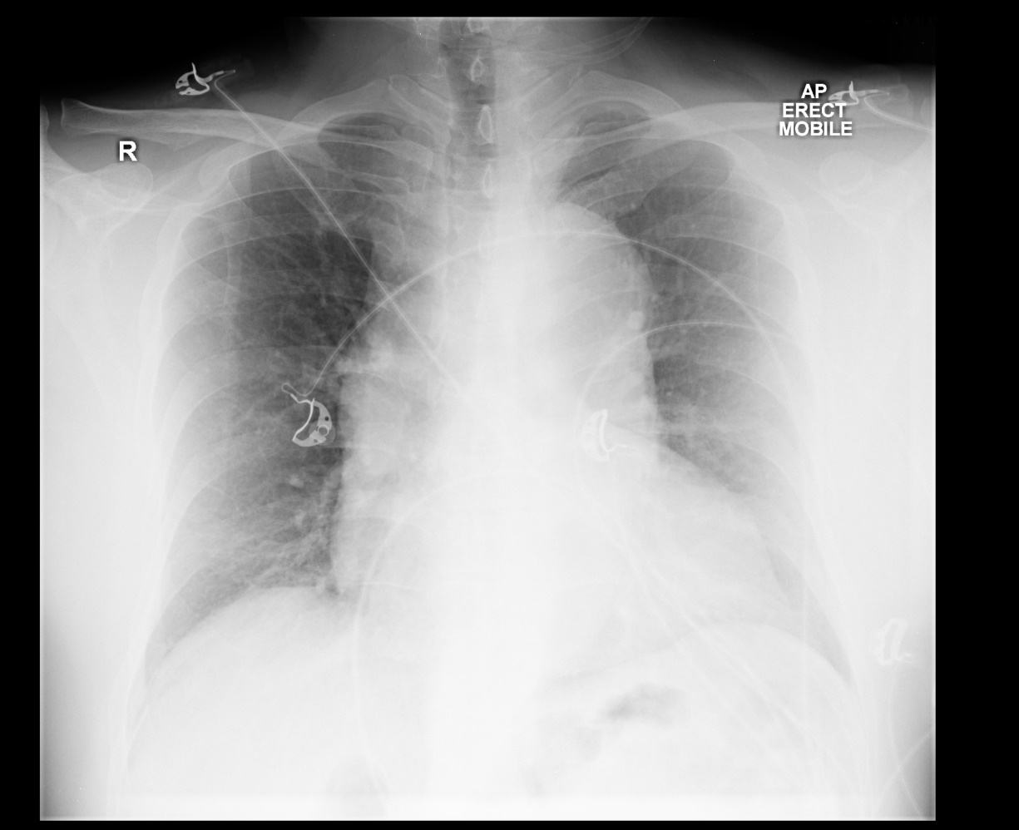

Image Source: WikiDoc

Q1. (1 pt) A 67 year-old male with a history of poorly managed hypertension and hyperlipidemia presents to the emergency department with ‘tearing’ chest pain that radiates to his back. A chest x-ray is obtained and shown. He has a 40 pack-year smoking history and a 5 year history of cocaine use. His pulses are weak and his temperature is 99.7 F. He previously took rosuvastatin but currently does not take any medications. Which of the following is the most likely diagnosis?

1. Pulmonary Embolism
2. Myocardial Infarction
3. **Aortic Dissection (Correct) – note the widened mediastinum present on the x-ray.**
4. Pleural Effusion
5. Cardiac Tamponade

Image Source: Plastic Surgery Key

Q2. (2 pts) A 45 year-old male is admitted due to ascending cholangitis. Due to difficulty obtaining peripheral intravenous access, a central line is placed via the patient’s right internal jugular vein. A CT of the chest is obtained. The contents from the central line will most directly drain into which of the following structures labeled on the CT?

A (this is a pulmonary artery)

**B (Correct) – this structure is the SVC**

C (this is the ascending aorta)

D (this is a pulmonary artery)

E (this is the descending aorta)

Q3. (2 pts) A 75 year-old male with a history of alcohol use disorder, hypertension, and atrial fibrillation is admitted to the hospital after CT scan revealed acute pancreatitis. Lipase and amylase are significantly elevated. During his third day after admission, he presents with fever, dyspnea, and altered mental status. Vitals show a blood pressure of 91/70, temperature of 101.3 F, and oxygen saturation of 80% on room air. The patient is intubated and a chest radiograph is obtained. Which of the following ventilator settings is most likely to reduce the risk of mortality for this patient?

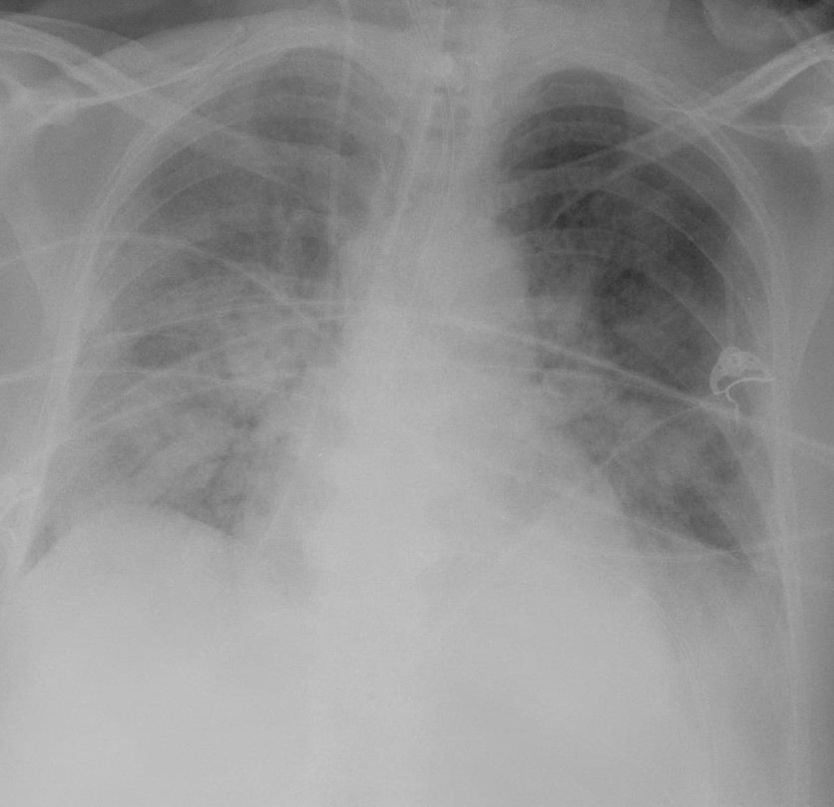

Image Source: Radiopaedia

1. Use High Tidal Volumes (e.g. 16 ml/kg); Position Patient Supine
2. Use High Tidal Volumes (e.g. 16 ml/kg); Position Patient Prone
3. Use Low Tidal Volumes (e.g. 6 ml/kg); Position Patient Supine
4. **Use Low Tidal Volumes (e.g. 6 ml/kg); Position Patient Prone –Correct, the bilateral ‘ground glass’ opacities pattern on the x-ray suggests ARDS. Using low tidal volumes (e.g. ‘the baby lung’ concept) and prone positioning will reduce the risk of mortality for ARDS patients.**

Image Source: RadioPaedia, courtesy of Dr Nikhil Rao

Q4. (1 pt) A 71 year-old female with a history of atrial fibrillation, hepatitis C, and gallstone disease presents to the hospital with epigastric pain that began 4 hours ago and radiates to her back. A CT scan of the abdomen is obtained and shown. Which of the following is the most likely diagnosis?

1. **Pancreatitis (Correct)**
2. Cholecystitis
3. Ascending Cholangitis
4. Mesenteric Ischemia
5. Perforated Gastric Ulcer

Q5. (3 pts) A 5 day-old female presents with a 1-day history of abdominal distention and blood within her stools. She was born at 30 weeks gestation and has been in the neonatal intensive care unit (NICU) since birth. She appears lethargic with a sunken fontanelle. An abdominal x-ray is performed and shown. Image Source: Rad Rounds

Part 1: (1.5 pts) Please identify the structure indicated by the arrows.

A) Ligamentum Teres Hepatis

B) Triangular Ligament

C) Coronary Ligament

**D) Falciform Ligament (Correct, this is the Falciform ligament of the liver. The prominence of this ligament is also known as the ‘Falciform Sign’ which suggests pneumoperitoneum)**

E) Cardinal Ligament

Part 2: (1.5 pts) Which of the following is the most likely diagnosis given this patient’s presentation and imaging findings?

A) Portal Hypertension

**B) Pneumoperitoneum (Correct, there is also a ‘Football Sign’ present in this x-ray. This infant most likely had necrotizing enterocolitis which can result in intestinal perforation and pneumoperitoneum). See this link for more info: https://radiopaedia.org/articles/football-sign-pneumoperitoneum?lang=us**

C) Intussusception

D) Hepatitis

E) Congenital Infection